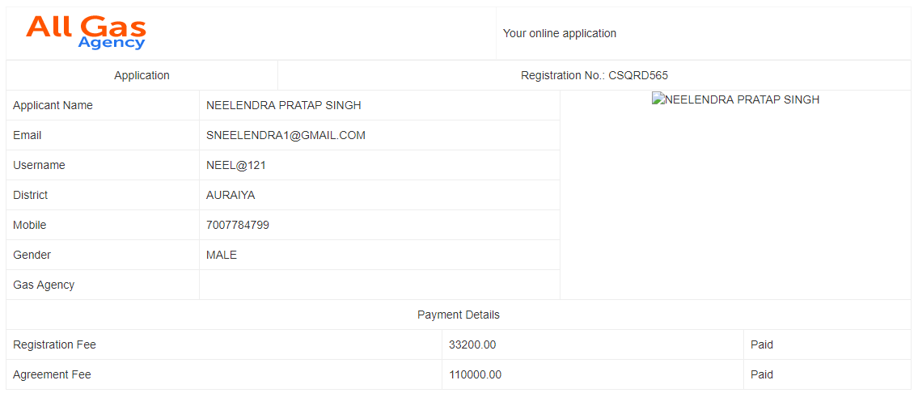

**PERSONAL DETAILS**

Applicant Name :-

Father Name

Aadhar No .

Pan no.

Email

COntact no

City

State

Ditrict

Pin code

Gender

Gas Agency

User name

Applicant Images

**Bank Details**

Bank Name

Account Holder Name

IFSC code

Branch Name

Address

Account Type

**Payment Details**

Registration fee 300 paid/unpaid

Agreement fee 400 paid/unpaid

**Download Option Particular User**

Image

Pdf

excel file

**Registrion No id : Generaion**

**Registration list**

**After registrion list when passs generat**